**Couple’s Cycle***Infinity diagram designed by Scott R. Woolley Ph.D.*

Partner 1

Withdrawer or Pursuer

**Partner 2**

Withdrawer or Pursuer

Overview of the couple’s particular cycle (its history, mechanisms, triggers, etc.)...

**Behaviors**

Description of these

**Perceptions**

Description of these

**Secondary Emotions**

Description of these

**Primary Emotions**

Description of these

**Unmet needs**

Description of these

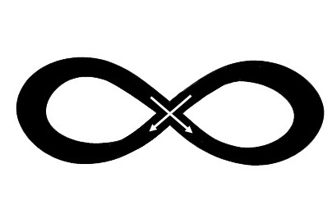

**Behaviors**

Description of these

**Perceptions**

Description of these

**Secondary Emotions**

Description of these

**Primary Emotions**

Description of these

**Unmet needs**

Description of these